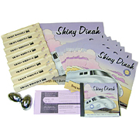
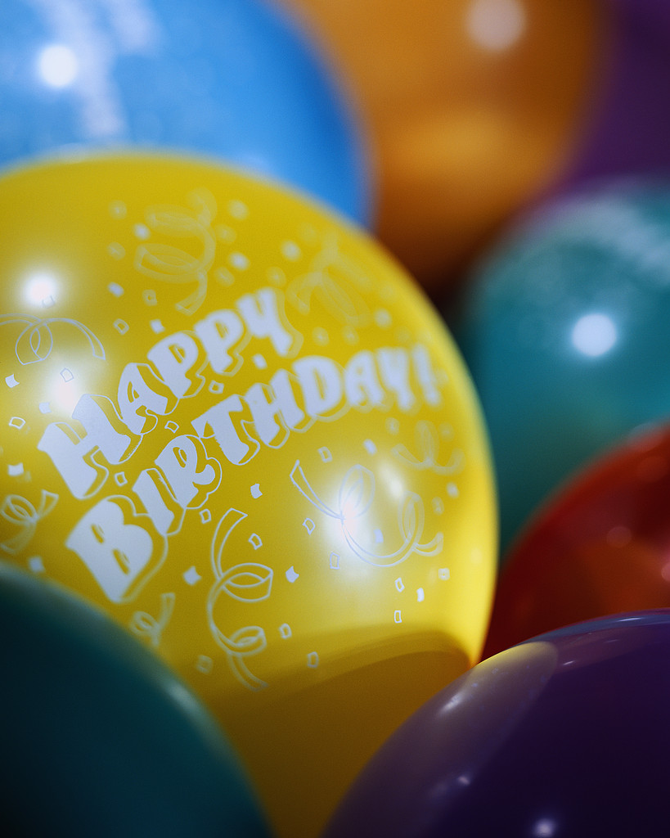
Your $175 PCU Birthday Package* Includes:
Miss Tracey/PCU staff comes with her instruments to lead a Kindermusik Music & Movement Story Time and optional Kindermusik and/or Sign & Sing class.

8 Birthday Favor Bags which include:
- A Shiny Dinah/other Kindermusik book
- A Shiny Dinah/Kindermusik CD
- A Kindermusik egg shaker instrument
- A Coupon for a FREE Kindermusik class!
- Optional additional items or activities available upon request☺. * As long as supplies last. Many other party themes and gift items possible! Now including a CD in every gift bag!

