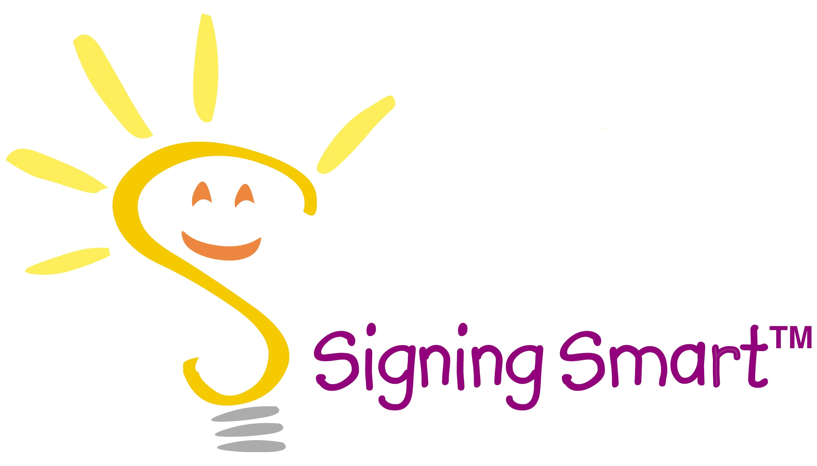

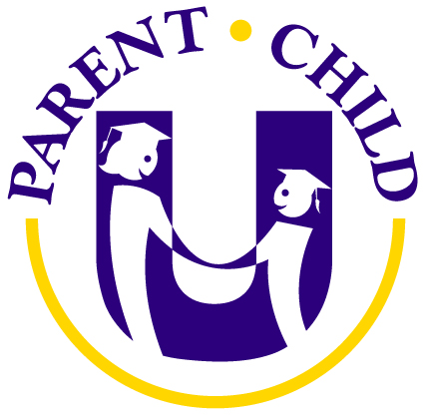
DADDY!
“I want to play with DADDY”
--12 months

Signing Smart™
PARENT WORKSHOP

EVERY PARENT WANTS THE BEST FOR THEIR CHILD…
GIVE YOURS THE GIFT OF COMMUNICATION

Facilitating hearing infants’ and toddlers’ communication and learning with Signing Smart™--
Infant/Toddler Sign Language is becoming a National Parenting Trend!

Signing Smart™
- Reduces frustration and tantrums
- Opens your child’s world and boosts self-esteem
- Promotes early communication—from 6 months & even earlier!
- Increases long-term learning abilities (NIH study showed a 12 point IQ increase!)
- Speeds spoken language development—research has shown that
Signing Smart™ children are early talkers!

Please check out www.ParentChildU.com email Classes@ParentChildU.com or call (571) 643-1002 to learn more or to sign up for a Play Class or Workshop!

Our CONDENSED 1.5 hour Workshop offers a fun, interactive session in which parents learn:
- How to utilize Signing Smart strategies and techniques to easily integrate signing into everyday life with your child
- The tools to start effortlessly and experience success rapidly
- How to recognize and identify your child’s early signs
- Twenty+ family-friendly American Sign Language signs
- How to recognize, respond to, and create interactions to allow your child to most easily learn and produce the signs, without your having to sign all the time!
- The strategies to make signing simple, fun, and interactive from the very first day!
- Your own personal Signing Smart™ Start to immediately get going with the program at home

“We started Signing Smart™ at birth. By almost 7 months old my daughter had several signs and could sign in 2 and 3 word sentences! By 12 months old she had over 100 words (signs and spoken)! Non-signing, typically developing, hearing children usually have 2-3 words by 12 months of age and are speaking in 2 word sentences between 18-24 months. Signing Smart™ is a phenomenal program that truly has allowed me to have a conversation with my baby!”
Tracey Kretzer, M.S., LPSC, Parent Child University, LLC Founder & Parent Educator

“I recommend Signing Smart. It promotes early communication and developmental learning, and it facilitates spoken language - from infancy through the preschool years!”
Dr. Jordan Klein, Partners in Pediatrics
© 2004 Wide-Eyed Learning, LLC
www.signingsmart.com

